**INTERNSHIP TITLE : LANDSLIDE PREDICTION**

**STUDENT NAME : MANAV N DULANI**

**CONTACT DETAILS : 8080911181**

**EMAIL ID :** [**2018.manav.dulani@ves.ac.in**](mailto:2018.manav.dulani@ves.ac.in)

**INDEX:**

|  |  |  |
| --- | --- | --- |
| Sr No. | TOPIC | Pg No. |
| 1 | INTRODUCTION   1. Existing problem 2. Overview 3. Purpose | 1  1  1 |
| 2 | Literature Review | 2,3 |
| 3 | Proposed Solution   1. Block diagram 2. Flowchart | 4  5 |
| 4 | Result | 6 |
| 5 | Advantages and disadvantages | 6 |
| 6 | Application | 6 |
| 7 | Conclusion | 7 |
| 8 | Refrence | 7 |
| 9 | Appendix   1. Source Code(WEB APP) 2. Source Code(Arduino Code) 3. Source Code(Python data upload) | 8,9  9,10  10,11 |

**INTRODUCTION :**

**Existing Problem :**

In INDIA there are many low lying areas which face lots of problems while monsoon, like landslides and lots of people get affected by it. So we have tried to create a system that would predict the landslide and help people to evacuate if they sense any risk.

**Overview** :

The aim of the system is to determine the probability of slope failure in terms of Landslide sucsceptibility mapping along a road section using moisture sensor, vibrational Sensors and wireless sensor networks(WSN) like wifi module and programmed with Arduino. It helps in ensuring safety for humans to alert them from landslides.

**Purpose** :

To reduce the losses caused to oth human and the city cused by the natural calamity landslide, by predicting its occurance.

**LITERATURE REVIEW :**

Landslides : A landslide is defined as the movement of a mass of rock, debris, or earth down a slope. Landslides are a type of "mass wasting," which denotes any down-slope movement of soil and rock under the direct influence of gravity. The term "landslide" encompasses five modes of slope movement: falls, topples, slides, spreads, and flows. These are further subdivided by the type of geologic material (bedrock, debris, or earth). Debris flows (commonly referred to as mudflows or mudslides) and rock falls are examples of common landslide types.

Almost every landslide has multiple causes. Slope movement occurs when forces acting down-slope (mainly due to gravity) exceed the strength of the earth materials that compose the slope. Causes include factors that increase the effects of down-slope forces and factors that contribute to low or reduced strength. Landslides can be initiated in slopes already on the verge of movement by rainfall, snowmelt, changes in water level, stream erosion, changes in ground water, earthquakes, volcanic activity, disturbance by human activities, or any combination of these factors. Earthquake shaking and other factors can also induce landslides underwater. These landslides are called submarine landslides. Submarine landslides sometimes cause tsunamis that damage coastal areas.

**SENSORS** :

1. Arduino Microcontroller
2. SOIL MOISTURE CONTROL
3. VIBRATIONAL SENSOR
4. ATMEGA 328 MICROCONTROLLER
5. MEMS ACCELEROMETER
6. ESPS8266 WIFI.

**Software** :

Proteus: The Proteus Design Suite is a proprietary software tool suite used primarily for electronic design automation. The software is used mainly by electronic design engineers and technicians to create schematics and electronic prints for manufacturing printed circuit boards.

Arduino Microcontroller : it is a open source computer hardware and software company, project and user community that designs and manufactures kits for building digital devices and interactive devices that can sense and control the physical world. Arduino boards cand be purchased or can be designed. The arduino board required for this project is

Microcontroller: ATmega328

**ESP8266 WIFI MODULE**: it is an impressive, low cost WIFI module suitable for adding WiFi functionality to an eisting microcontroller project via a UART serial connection. It can be even programmed to act as a standalone WiFi connected device just add power.

**Soil Moisture Sensor** : it is an electronic brick is an electronc module which can be assembled like lego bricks Simply by plugging in and pulling out. Compared to traditional universal boards and circuit modules Assembled wih various electronic components,which help in detecting the misture content in the soil. The control board can get the moisture value or threshold in the soil via analog or digital pins.

**VIBRATION SENSOR** : A piezoelectric effect to measure the pressure uses the acceleration, strain or force by converting them to an electric charge.It exploits the piezoelectric property of the piezo electric crystals.the piezoelectric effect could be direct in which the electric charge develops or indirect piezoelectric effect in which a In which a mechanical force such as pressure develops due to the application of an electric field.

**TEST SETUP** :The power supply is applied to the microcontroller generally the the preferred microcontroller is arduino. We have to uload Water level detector program to the arduino and open the serial plotter from the arduino. The components are placed in the dot board and soldered according to the circuit diagram. The power supply is given to Vin port. The positive of level sensor is connected to Vcc port.

For the Node 2 we use arduino as microcontroller. We have to upload vibrational detector program to the rduino and open the seria plotter from the arduino tool list . then we have to burn the program to arduino. The components are placed in dot bord and soldered according to the circuit diagram. The power supply is given to Vin port. The positive of vibration sensor is connected to the vcc port.

We have to set the location of the kit in thingspeak portal. The kit connects with port through wifi module. The level sensor shows te rise in water level and the result are obtained in the form of graph.

**PROPOSED SOLUTION :**

**BLOCK DIAGRAM:**

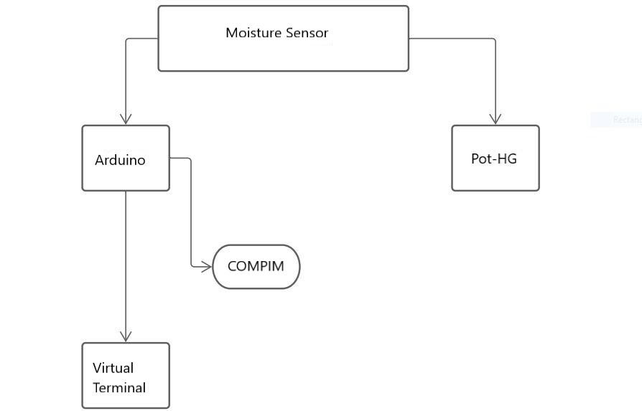

**FLOW CHART :**

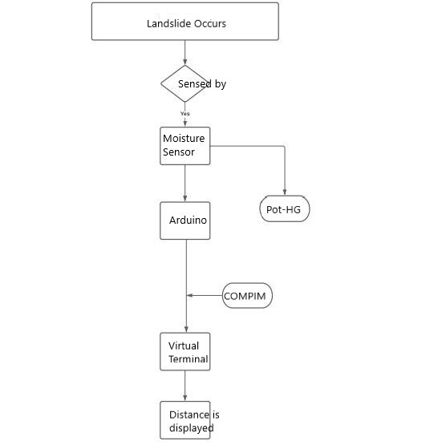

**RESULT :**

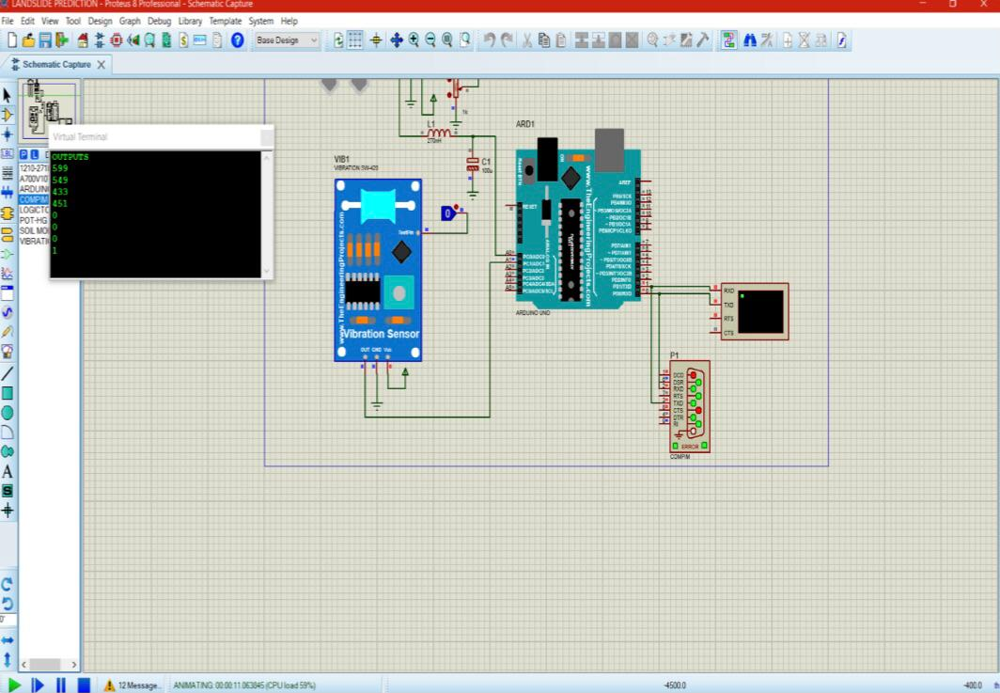

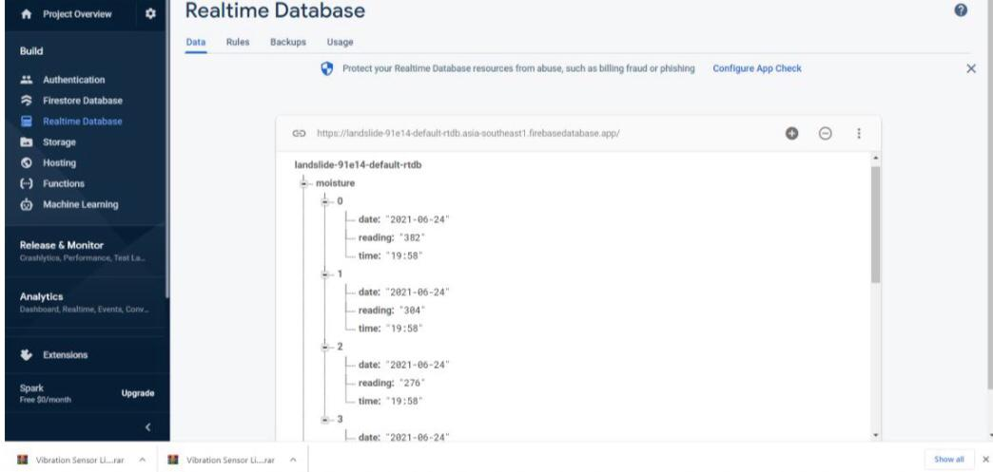

**LINK OF WEB APPLICATION :** **https://nervous-neumann-7abce3.netlify.app/**

**ADVANTAGES :**

1. Helps in preventing human loss by evacuating the affected area by predicting the landslides.
2. Can help in saving economy of the country.

**DISADVANTAGE** :

1. Can have loss of time by false predictions .
2. The accuracy of the system is not 100%

**APPLICATION :**

1. Can be used by Meteorological Department to have proper security measures

**LEARNING OUTCOMES :**

1. From this internship I learnt about how to approach the problem while doing something.
2. How to look about relevant sources on the web.
3. How to work on deadline based tasks .

**REFERENCES :**

1. <https://www.usgs.gov/faqs/what-a-landslide-and-what-causes-one?qt-news_science_products=0#qt-news_science_products>
2. Paper published by S.Srinath, M.Vignesh , T.Vijyan <https://ijmtes.com/wp-content/uploads/2016/06/IJMTES030933.pdf>

**Appendix :**

Arduino code **:**

**int i,j,moistvalue,vibrationvalue;**

**void setup() {**

**Serial.begin(9600);**

**Serial.println("OUTPUTS");**

**}**

**void loop() {**

**delay (5000);**

**for (i=0;i<4;i++)**

**{moistvalue=analogRead(A0);**

**Serial.println(moistvalue);**

**delay(500);**

**}**

**for (j=0;j<4;j++)**

**{**

**vibrationvalue=digitalRead(A1);**

**Serial.println(vibrationvalue);**

**delay(500);**

**}**

**}**

WEB APPLICATON CODE **:**

**<!DOCTYPE html>**

**<html>**

**<head>**

**<link rel="stylesheet" href="styles.css">**

**<link rel="stylesheet" href="https://maxcdn.bootstrapcdn.com/bootstrap/3.3.7/css/bootstrap.min.css">**

**<script src="https://canvasjs.com/assets/script/canvasjs.min.js"></script>**

**<script src="script.js"></script>**

**</head>**

**<body>**

**<h1>Sensor Data Plotting</h1>**

**<div class="row" style="padding:10px 10px 10px 10px;">**

**<div class="jumbotron" style="height:600px;margin-left:20px;margin-right:20px;border-radius:20px;width:1000px;">**

**<p>MOISTURE SENSOR </p>**

**<hr>**

**<label>Please Select the date:-</label><input type = "date" id="demo">**

**<button class="btn btn-success" type="button" onclick="myFunction()">Plot data</button>**

**<br><br>**

**<div id="chartContainer"></div>**

**</div>**

**<div class="jumbotron" style="height:600px;margin-left:20px;margin-right:20px;border-radius:20px;width:1000px">**

**<p>VIBRATION SENSOR </p>**

**<hr>**

**<label>Please Select the date:-</label><input type = "date" id="demo2">**

**<button class="btn btn-success" type="button" onclick="myFunction2()">Plot data</button>**

**<br><br>**

**<div id="chartContainer2"></div>**

**</div>**

**</div>**

**</body>**

**</html>**

Python code **:**

**import serial**

**from firebase import firebase**

**from time import sleep**

**from datetime import datetime**

**import serial.tools.list_ports**

**ports = serial.tools.list_ports.comports()**

**for port, desc, hwid in sorted(ports):**

**print("{}: {} [{}]".format(port, desc, hwid))**

**ser = serial.Serial("COM2", 9600)**

**print(ser.readline())**

**res = 1**

**i = 0**

**time = datetime.now().strftime("%d-%m-%Y %H:%M:%S")**

**print(time)**

**while res:**

**cc = str(1234)**

**print(cc)**

**val = cc**

**firebase1 = firebase.FirebaseApplication('https://landslide-91e14-default-rtdb.asia-southeast1.firebasedatabase.app/', None)**

**for i in range(0, 4):**

**#string1 = "123"**

**string1=str(ser.readline())**

**string1=string1[2:][:-5]**

**data = {'date': datetime.now().strftime("%Y-%m-%d"),**

**'reading': string1,**

**'time': datetime.now().strftime("%H:%M")**

**}**

**result = firebase1.patch(**

**'https://landslide-91e14-default-rtdb.asia-southeast1.firebasedatabase.app/' + '/moisture/' + str(i), data)**

**print(result)**

**for i in range(0, 4):**

**#string2 = "123"**

**string2=str(ser.readline())**

**string2=string2[2:][:-5]**

**data1 = {'date': datetime.now().strftime("%Y-%m-%d"),**

**'reading': string2,**

**'time': datetime.now().strftime("%H:%M")**

**}**

**result1 = firebase1.patch('https://landslide-91e14-default-rtdb.asia-southeast1.firebasedatabase.app/' + '/vibration/' + str(i),**

**data1)**

**print(result1)**

**res = 0**